|  |  |  |
| --- | --- | --- |
|  | **Year 11 Mathematics**  **Methods Unit 1** | **Test 1**  Term 1, 2021  Test date: Thursday 4th March |

Student Name: ______________________________________________________________________

|  |  |  |  |
| --- | --- | --- | --- |
|  | Total | Result | **%** |
| Section 1 | 17 |  |
| Section 2 | 33 |  |
| Total | 50 |  |

*All working must be shown in the space provided. Your working should be in sufficient detail to allow your answers to be checked readily and for marks to be awarded for reasoning. Incorrect answers given without supporting reasoning cannot be allocated any marks. For any question or part question worth more than 2 marks, valid working or justification is required to receive full marks.*

|  |  |
| --- | --- |
| **Section 1: Resource – Free** | **Working time: 20 minutes** |

**Question 1 [1, 2, 2, 2 = 7 marks]**

Consider the two right triangles shown below.

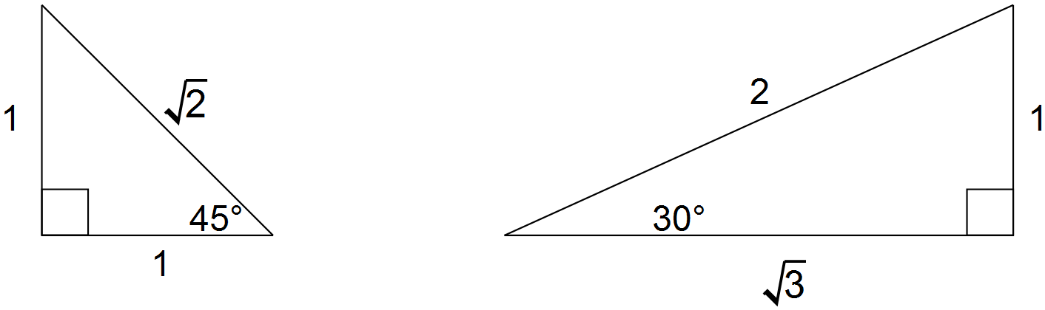

Use the triangles above and reference angles to determine the **exact** value of

(a) cos 60°

(b) sin 225°

(c) θ , where tan θ =  for 0 ≤ θ ≤ 360°

(d) Use the triangle from page 1 (showing an angle of )

to demonstrate that

**Question 2 [1, 2 = 3 marks]**

Use the unit circle below to answer the questions on the right.

Give your answers to an appropriate degree of accuracy.



(a) Determine the value of sin 120°

(b) Solve for where

**Question 3 [2 marks]**

(a) Convert radians to degrees

(b) Express to radians , as a fraction of

**Question 4 [3, 2 = 5 marks]**

(a) Find the exact value of showing full setting out.

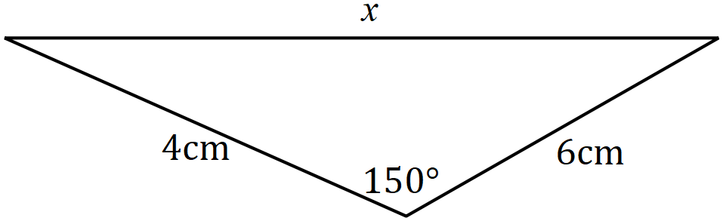

(b) Calculate the area of the triangle.

**End of Section 1**

|  |  |  |
| --- | --- | --- |
|  | **Year 11 Mathematics**  **Methods Unit 1** | **Test 1**  Term 1, 2021  Test date: Thursday 4th March |

Student Name: ______________________________________________________________________

|  |  |  |  |
| --- | --- | --- | --- |
|  | Total | Result | **%** |
| Section 1 | 17 |  |
| Section 2 | 33 |  |
| Total | 50 |  |

*All working must be shown in the space provided. Your working should be in sufficient detail to allow your answers to be checked readily and for marks to be awarded for reasoning. Incorrect answers given without supporting reasoning cannot be allocated any marks. For any question or part question worth more than 2 marks, valid working or justification is required to receive full marks.*

|  |  |
| --- | --- |
| **Section 2: Resource – Rich** | **Working time: 35 minutes** |

**Question 1** **[8 marks]**

(a) Determine the area of triangle when , and cm.

(4 marks)

(b) The area of triangle is cm2, and as shown in the diagram. Determine the value of and then calculate the length of . (4 marks)

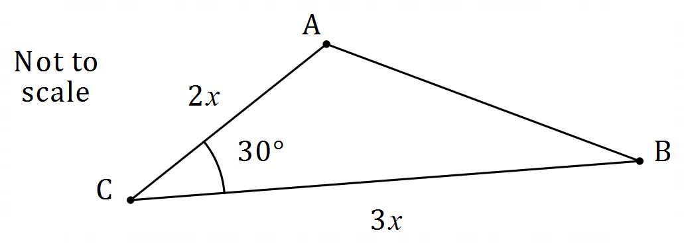

**Question 2** **[2, 3 = 5 marks]**

A segment of a circle of radius cm is shown below, where .

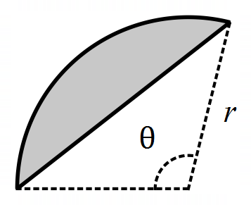

(a) Determine the area of the segment. (2 marks)

(b) Determine the perimeter of the segment. (3 marks)

**Question 3** **[5 marks]**

Shape below consists of sector of circle centre joined to sector of a different circle, also centre . is a line of length cm, arc is cm long and radians.

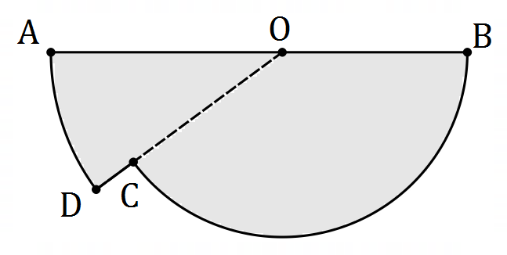

(a) Determine the length . (2 marks)

(b) Determine the area of the shape. (3 marks)

**Question 4** **[3 marks]**

Calculate, to the nearest degree, the acute angle between the line

and the line .

**Question 5** **[6 marks]**

Determine, correct to 2 decimal places, the length of side BD in the diagram below.

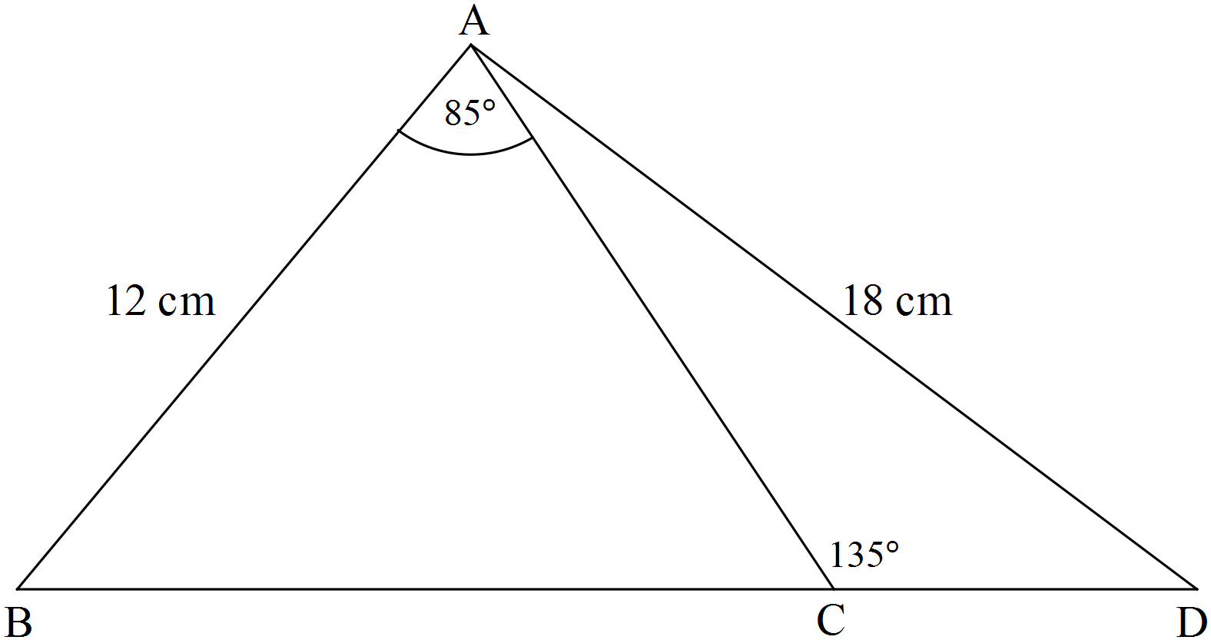

Note: the diagram is not drawn to scale.

**Question 6** **[1, 2, 3 = 6 marks]**

A boat sails from A in the direction for 40 km. It then sails along for 100 km.

(a) Complete the diagram below to show this information. (1 mark)

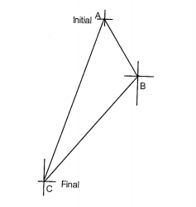

(b) Calculate the direct distance between A and its final position. (2 marks)

(c) Find the **bearing** of A from its final position. (3 marks)

**End of Section 2**